Project Two: Analyzing Databases

By Stephen Johnson

*(a)*

To begin the project, after entering **mysql;**, the following statement was used to capture usable data:

**USE QuantigrationRMA;**

I used the above command to change to the QuantigrationRMA database. The command **show tables;** was used to display the tables Collaborators, Customers, Orders, RMA. The Orders table will be used in the next two screenshots.

*(b)*

(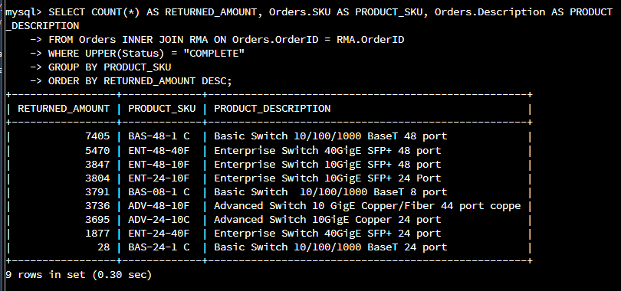

For this screenshot, the following command was entered to analyze the return amount by state:

**SELECT COUNT(*) AS RETURNED_AMOUNT, Orders.SKU AS PRODUCT_SKU, Orders.Description AS PRODUCT_DESCRIPTION**

**FROM Orders INNER JOIN RMA ON Orders.OrderID = RMA.OrderID**

**WHERE UPPER(Status) = "COMPLETE"**

**GROUP BY PRODUCT_SKU**

**ORDER BY RETURNED_AMOUNT DESC;**

As seen above, 7405 is the highest amount returned and 28 is the least returned. All returned amounts are shown with their respective product and product description.

*(c)*

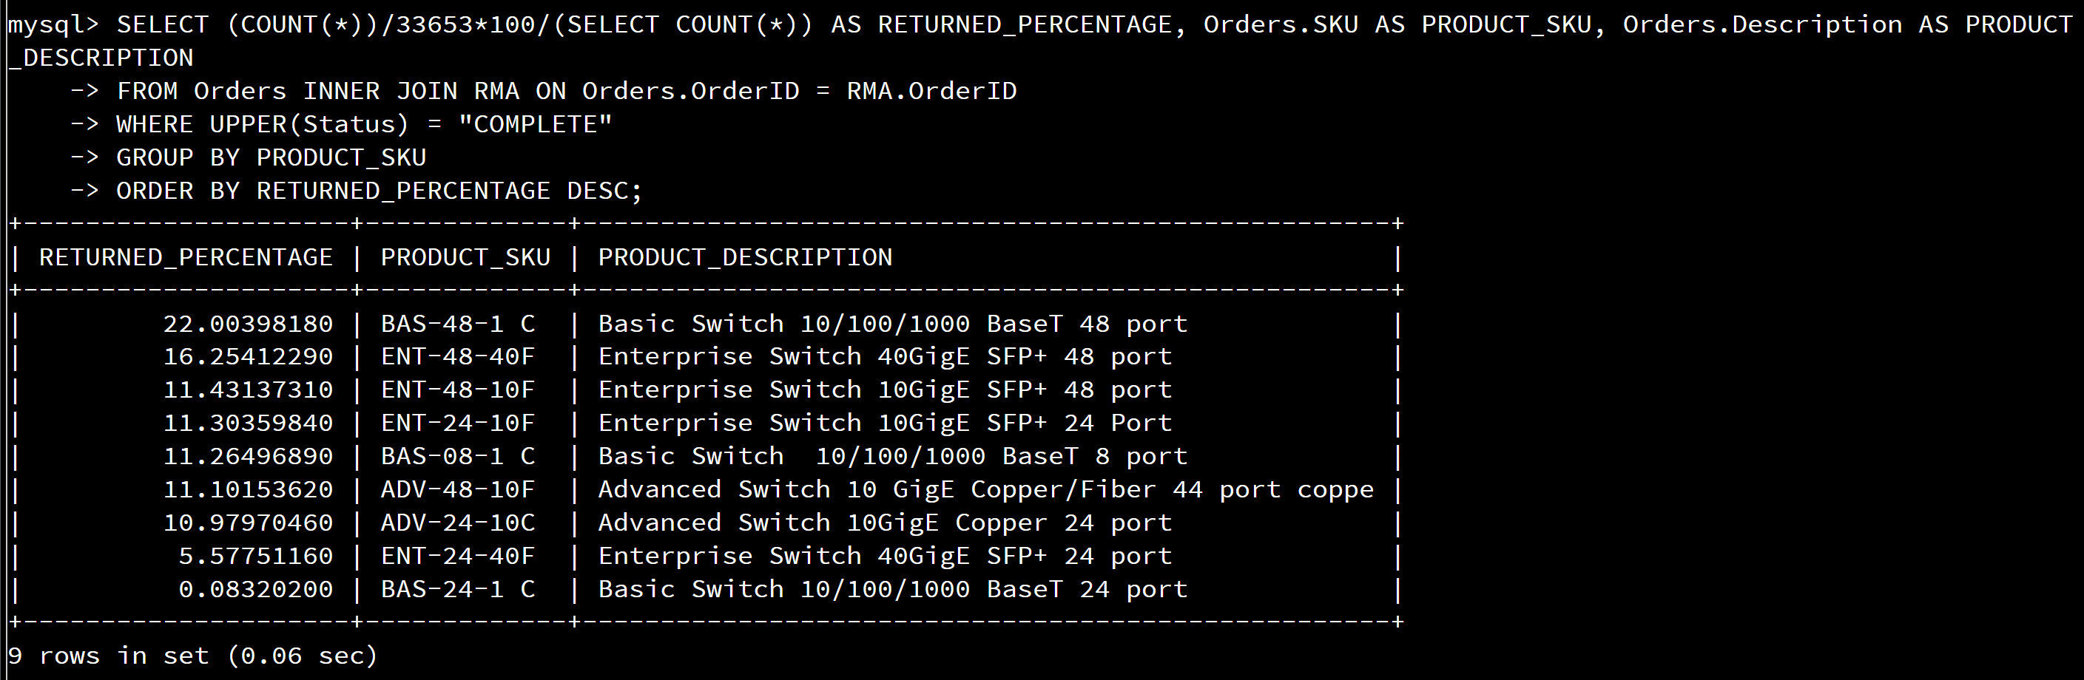

Finally, the following command helped me determine the percentage of the returned amount for each product:

**SELECT (COUNT(*))/33653*100/(SELECT COUNT(*)) AS RETURNED_PERCENTAGE, Orders.SKU AS PRODUCT_SKU, Orders.Description AS PRODUCT_DESCRIPTION**

**FROM Orders INNER JOIN RMA ON Orders.OrderID = RMA.OrderID**

**WHERE UPPER(Status) = "COMPLETE"**

**GROUP BY PRODUCT_SKU**

**ORDER BY RETURNED_PERCENTAGE DESC;**

This information is like the previous screenshot; however, the difference is the Returned Amount being converted to Returned Percentage. For example, the 7405 Returned Amount is changed to 22% or 22.00398180 and the least returned amount, 28, is converted to 0.08320200. While I was unable to add a percentage sign, I was able to give a close number for percentage with the decimal characteristics.

Analysis Summary

Computer databases accumulate an amass of data records or a notebook that consists of information. This includes sales transactions, customer and financial data, and product information. Databases are used for depositing, preserving, and gaining connection to any sort of data, gathering data on people, places and/or things.

There are potential flaws in the data that has been processed which can be frequent upgrades of information and complexity of presented data. After information such as the returned amount is demonstrated, new information could be introduced by the end of the week (for example). Additionally, the translation of presented data can be misinterpreted, confusing company associates and stakeholders.

However, the data does have a high chance of security, as well as rapid development for the database. The information presented and stored in the database is very secure with the sensitive data having protection from data breaches and any security issues. While there could be constant updates in the presented data, database technology allows the capability and capacity to easily update this information, also acting as an advantage. The information displayed from the database assists in providing knowledge that can potentially and effectively increase profit for any company.